**CHAPTER 1**

**INTRODUCTION**

**1. Environmental and Sustainability Goals**

* Aimed to **enhance the local environment** and promote **sustainable ecological practices**.
* Focused on **increasing green cover** through **systematic tree plantation**.
* Ensured saplings received **proper nutrients and care** for healthy growth.

**2. Strategic Planting Approach**

* Used **natural and organic elements** such as:
  + **Compost**
  + **Coconut dry shells**
  + **Manure**
* Improved **soil fertility** to support **sustained plant growth**.
* Aimed to create a **self-sustaining ecosystem** benefiting:
  + **Cleaner air**
  + **Increased biodiversity**
  + **Improved soil health**

**3. Community Education and Engagement**

* Provided **environmental education** to local residents.
* Encouraged **sustainability awareness** through hands-on participation.
* Volunteers were **divided into specialized teams** with assigned tasks:
  + **Planting saplings**
  + **Distributing manure**
  + **Documenting progress**

**4. Promoting Collective Action and Responsibility**

* Highlighted the **power of teamwork** in tackling environmental concerns.
* Instilled **a sense of responsibility and ownership** among participants.
* Encouraged participants to **adopt environmentally conscious habits** in daily life.

**5. Long-Term Impact and Sustainability**

* Established a foundation for **continued environmental efforts** in Gudemaranahalli.
* Served as a **model initiative** for future ecological conservation projects.

**CHAPTER 2**

**OBJECTIVES**

**1. Enhancing the Local Environment**

* **Expanding Green Cover** – Increased tree plantations for a greener, healthier environment.
* **Improving Soil Health** – Used organic materials like **compost, coconut dry shells, and manure** to enrich soil fertility.
* **Preventing Soil Erosion** – Tree roots helped **bind the soil**, reducing erosion and improving land stability.
* **Enhancing Air Quality** – Planted saplings **absorbed carbon dioxide and released oxygen**, contributing to cleaner air.
* **Supporting Local Biodiversity** – Created a habitat for **local wildlife**, maintaining ecological balance.

**2. Promoting Sustainable Agricultural Practices**

* **Organic Soil Enrichment** – Used natural fertilizers instead of chemicals for sustainable farming.
* **Water Conservation** – Trees improved **water retention** in soil, reducing excessive irrigation needs.
* **Encouraging Agroforestry** – Integrated tree planting with farming for **mutual benefits to crops and the environment**.
* **Long-Term Carbon Sequestration** – Trees acted as **carbon sinks**, absorbing greenhouse gases and combating climate change.

**3. Educating the Community**

* **Raising Awareness** – Provided **hands-on learning** about environmental conservation.
* **Encouraging Responsibility** – Taught participants to **nurture saplings for long-term survival**.
* **Demonstrating Practical Techniques** – Trained community members in **planting methods, soil management, and tree care**.
* **Showcasing Sustainable Practices** – Highlighted **composting and organic fertilization** to promote natural plant growth.

**4. Fostering Community Engagement**

* **Strengthening Social Bonds** – Brought people together through **teamwork and collaboration**.
* **Encouraging Volunteerism** – Participants gained **fulfillment and motivation** from contributing to a meaningful cause.
* **Inspiring Future Initiatives** – The success of the drive set a **precedent for future environmental efforts**.
* **Encouraging Intergenerational Participation** – Included **people of all ages**, fostering a habit of environmental stewardship.
* **Empowering Local Leadership** – Encouraged **community ownership**, improving leadership skills and confidence.

**5. Long-Term Sustainability and Impact**

* **Creating a Greener Future** – Trees planted will **contribute to environmental improvements over time**.
* **Encouraging Ongoing Maintenance** – Emphasized the importance of **watering and protecting saplings** regularly.
* **Building a Resilient Ecosystem** – More trees improved **climate resilience**, helping the community adapt to environmental changes.
* **Setting a Model for Other Communities** – The success of the initiative **serves as an inspiration** for other regions to implement similar projects.

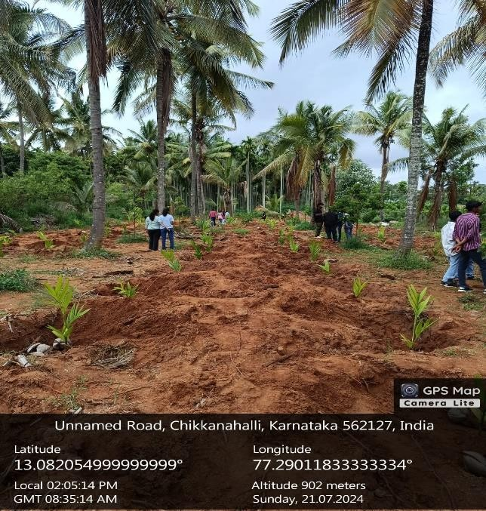

**CHAPTER 3**

**ABOUT THE PLACE**

**1. Location and Landscape**

* Located in **Chikkaballapur district, Karnataka, India**.
* Picturesque rural setting with **lush farmlands and rolling hills**.
* Part of the **Chikkaballapur taluk**, known for its **serene countryside beauty**.

**2. Agriculture and Economy**

* Farming is the **backbone of the local economy**.
* Major crops cultivated include **paddy, ragi, maize, and vegetables**.
* Blend of **traditional and modern farming practices** to ensure productivity.
* Many families involved in **dairy farming, trade, and agriculture-related occupations**.

**3. Cultural Significance and Traditions**

* Rich in **Kannada culture**, with traditions passed down through generations.
* Major festivals celebrated with enthusiasm:
  + **Ugadi (Kannada New Year)**.
  + **Deepavali (Festival of Lights)**.
  + **Sankranti (Harvest Festival)**.
* Local **fairs and religious ceremonies** strengthen community bonds.
* **Temples and places of worship** play a central role in spiritual and social life.

**4. Infrastructure and Connectivity**

* Evolving infrastructure with **developing roads, schools, and healthcare centers**.
* Limited access to urban conveniences but **essential services are available**.
* **Road networks connect** the village to nearby urban centers for **trade, education, and healthcare**.

**5. Natural Beauty and Environment**

* Surrounded by **vast green fields and gently rolling hills**.
* Offers a **peaceful retreat from urban life**.
* Preserves the **unspoiled charm of Karnataka’s countryside**.

**6. Essence of Rural Karnataka**

* Represents the **traditional agrarian lifestyle** of Karnataka.
* **Strong cultural and agricultural foundation** sustains village life.
* **Harmonious blend of nature, tradition, and rural livelihood**.



**CHAPTER 4**

**ACTION PLAN**

|  |  |  |  |
| --- | --- | --- | --- |
| **SLNO** | **DATE** | **ACTIVITY** | **DURATION** |
| 1 | 20/07/2024 | Taking permission from panchayat | 8 |
| 2 | 21/07/2024 | Activity planning | 8 |
| 3 | 22/07/2024 | Collecting samples | 8 |
| 4 | 23/07/2024 | Discovering plantation sites | 8 |
| 5 | 24/07/2024 | Digging lands | 8 |
| 6 | 25/07/2024 | Digging lands | 8 |
| 7 | 26/07/2024 | Planting samplings | 8 |
| 8 | 27/07/2024 | Planting samplings | 8 |
| 9 | 28/07/2024 | Watering | 8 |
| 10 | 29/07/2024 | Report Making | 8 |
| 11 | 20/07/2024 – 28/07/2024 | Travel to location | 10 |

**CHAPTER 5**

**CONDUCTION OF THE ACTIVITY**

**1. Preparation Phase**

* **Site Selection and Pit Digging**
  + Identified suitable locations for planting saplings.
  + Dug pits to the appropriate depth for healthy plant growth.
* **Material Transportation**
  + Transported necessary resources such as **compost, dried coconut shells, and manure**.
  + Ensured all materials were available **on time and in the required quantity**.

**2. Team Formation and Task Allocation**

* Participants were divided into specialized teams for **efficient execution**:
  + **Plantation Team** – Planted saplings at the correct depth while maintaining proper spacing.
  + **Manure Distribution Team** – Applied compost, dried coconut shells, and manure to enhance soil quality.
  + **Mulching Team** – Spread mulch around plants to **retain soil moisture, suppress weed growth, and improve soil health**.
  + **Media Team** – Documented the event through **photographs and videos** to spread awareness.

**3. Implementation Phase**

* **Planting and Mulching**
  + Teams worked together to plant saplings and cover the soil with mulch for protection.
* **Nutrient Application**
  + The manure distribution team **enriched the soil with compost and organic materials**.
* **Supervision and Coordination**
  + Team leaders **oversaw activities**, resolved issues, and ensured tasks were completed on time.

**4. Challenges Encountered**

* **Logistical Challenges**
  + Difficulty in **transporting materials** to the site required efficient scheduling.
  + Ensuring **sufficient tools and equipment** for all participants required careful coordination.
* **Unfavorable Weather Conditions**
  + **Heavy rain or extreme heat** disrupted the plantation schedule.
  + Protective measures were taken to **shield saplings from harsh environmental conditions**.
* **Team Coordination Issues**
  + Managing multiple teams and ensuring smooth collaboration was **complex**.
  + Avoiding **delays and task overlaps** required strong leadership and effective communication.

**OUTCOMES**

**1. Success of the Initiative**

* Demonstrated the **power of collective effort and strategic environmental action**.
* Enriched the **local ecosystem** through meticulous planning and teamwork.
* Used **compost, coconut dry shells, and manure** to nourish saplings and ensure their long-term survival.

**2. Community Engagement and Awareness**

* Actively involved individuals in **planting, distributing nutrients, and documenting the event**.
* Strengthened the **bond between people and nature** by fostering environmental awareness.
* Addressed **execution challenges with resilience and teamwork**, reinforcing adaptability in environmental initiatives.

**3. Future Actions for Long-Term Impact**

* **Regular follow-up efforts** to maintain and monitor sapling growth.
* **Community-driven activities** to sustain engagement and environmental awareness.
* Encouraging long-term **participation in afforestation programs** to maximize ecological benefits.

**4. Long-Term Vision and Sustainability**

* Contributes to **biodiversity, cleaner air, and a healthier ecosystem**.
* Represents a **step toward long-term environmental stewardship**.
* Potential to create a **lasting ecological legacy** for future generations.
* If sustained and expanded, such initiatives can lead to a **greener and more sustainable world**.

Bottom of Form